EMERGENCY PLAN

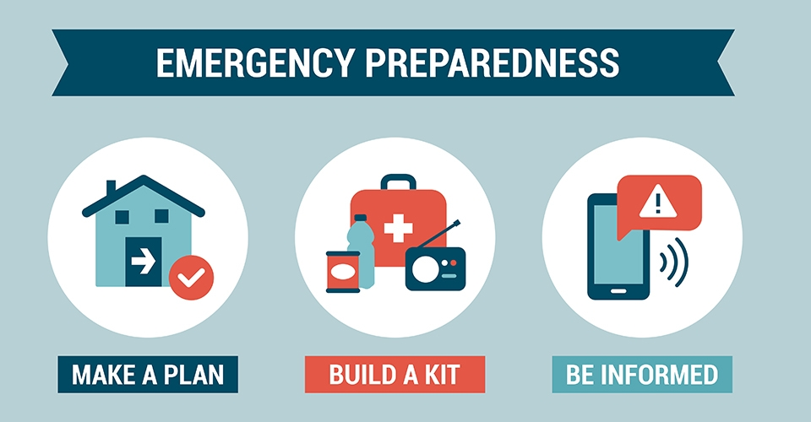

<Name of Licensed Child Care Facility>
<Owner/Operator/Director First and Last Name>
<Address>
<City, State, Zip>
<Telephone>
<Email Address>

<Date of Plan>

DISASTER AND EMGERGENCY
PLAN FOR
<Name of licensed child care facility>

- Purpose

This emergency plan has been developed to assist <Name of licensed child care facility> in protecting the health and safety of the children in its care should a disaster or emergency, be it natural or deliberate, affect the facility, operation or its community. The safety of the children and staff is the primary goal of <Name of licensed child care facility>.

- Assignment of Responsibilities

<Staff members> are responsible for implementing the disaster and emergency plan and ensuring the safety of the children.

It is the responsibility of all staff to understand their roles and responsibilities and the location of the supplies in the event of an emergency.

- Location of Daily Children’s Attendance, Emergency Contacts and Emergency Supplies

Children’s daily attendance records are kept <location of attendance records>. The children’s attendance records are updated as they arrive and leave throughout the day.

Children’s Emergency Contact Information is kept <location of emergency contact information>.

In a widespread disaster, we need to be prepared to care for the children in the facility until assistance arrives. Emergency supplies are stored <location of emergency supplies>. These supplies are updated every six months.

- Children in Care

All children in care are between the ages of <ages of children>. We <have/have no> special needs children. We <offer/do not offer> overnight care.

- Emergency Assessment

Below is a list of possible disaster or emergencies that may affect the area.
(Boxes will expand as you enter your procedures for each possible disaster.)

Types of emergencies and/or Hazardous situations

- Fire / Smoke | - Tornado – Watch / Warning | - Missing Child (Kidnapping)
- Carbon Monoxide Exposure | - Chemical Spill/ Hazardous Material Exposure | - Power Failure
- Intruder | - Medical Emergencies | - Bomb Threat
- Earthquake | - Flooding | - Gas Leak
- Ice and Snow Storms | - Potentially Violent Situation | - Water Line Disturbance
- Disgruntled Employees | - Disgruntled Parents/ Guardians | - Other

- Types of Emergency Response

Medical Emergencies

Assess the situation and contact 911, if necessary. Notify the parent’s immediately. Document the date and circumstance regarding the medical emergency in the child’s record.

Lock Down / Shelter in Place

Location: <location>
Code Word: <code word>

All staff are to stay in the lock down / shelter in place areas until an all clear is given.

Evacuation

Evacuate the facility to go to another location nearby or far away to remain safe. Evacuation maps are posted by all doorways. The map outlines where the staff and children will go in the event of an evacuation emergency.

Fire and smoke will be announced by the alarm system, isolation of fire and smoke would include confinement by closing doors to the fire area. An emergency phone call will be made to appropriate emergency personnel.

Two off-site locations are listed below:

1st Evacuation Location
Location: <Location>
Address: <Physical Address>
City, State Zip: <City, State, Zip>
Telephone Number: <Telephone Number>

2nd Evacuation Location
Location: <Location>
Address: <Physical Address>
City, State Zip: <City, State, Zip>
Telephone Number: <Telephone Number>

Evacuation from a vehicle

- Staff Training & Monthly or Quarterly Drills

All staff and children will participate in fire and disaster drills at the facility. Fire drills will be conducted monthly and disaster drills every three months. All drills must be documented. In addition to these drills, fire alarm and extinguisher training will be completed.

- Access to Disaster and Emergency Preparedness Plan

A copy of the Disaster and Emergency Preparedness Plan will be available, at all times, in the office and each room used for child care.
<Facility Name>
<Facility Address>
<Facility Phone Number>

Emergency Contact Numbers

All Emergencies 911
Poison Control Center 1-800-366-8888
Fire Department <Number>
Police Department <Number>
Ambulance Service <Number>
<Local Media> <Number>

Child Care Facility Specialist <Name> <Number>

Owner/Manager of building <Name> <Number>
Principle place of business (if operated at more than one location)
<Name> <Number>

Parent / Guardian Contact Information
Child’s Name | Parent’s Name | Special Care | Phone Number | Emergency Contact | Emergency Number
<Date>

Dear Parent / Guardian:

In the event of an emergency situation, <Name of Facility>, has outlined the below response plan. Please know that <Name of Facility>, will make every attempt to notify you so it is vital that you keep your emergency contact information up-to-date. Keep this letter with you so that you will know how to contact us in the event of an emergency.

Evacuation / Relocation
- If the emergency is confined to the immediate area at the <Name of Facility>, e.g. fire, and the children cannot stay on the premises, the children will be taken to <Name of off site location>. The children and staff will remain at this location while you or your emergency contact is notified of the situation.
- If the emergency is more wide spread and encompasses a larger area such as the neighborhood due to an environmental threat, e.g. flood, and the children cannot remain in the immediate area, they will be transported to <Name of off site location>. The children and staff will remain at this location while you or your emergency contact is notified of the situation.

Notification
- Every effort will be made to contact you as soon as the children and staff are safe. If we cannot reach you, we will contact your alternate emergency contact. Children will only be released to you or your alternate emergency contact during times of emergency.
- Information about the event can be obtained through radio stations, <list radio stations>.

Emergency Supplies
- We encourage you to bring individual emergency packs for each child to keep at our facility that includes a change of clothes, a few family photos and a comfort item like a small teddy bear to help comfort your child during a crisis. These individual packs will be stored in our safe room and only accessed during an emergency.

Please rest assure that <Name of Facility> staff will remain with and care for the children at all times during an emergency to ensure the children’s safety. As always, please don’t hesitate to contact me if you have any questions or concerns.

Sincerely,

<Director/Owner>

Diagram of Routes to Safe Location inside the Facility

Diagram of Exit Routes to Safe Location Outside of Facility

