Florida Early Childhood Education Training Stipend FAQ’s

Q1) What is the Florida Early Childhood Education Training?
The Division of Early Learning (DEL) and the Early Learning Coalition are partnering with the University of Florida Lastinger Center (UFLC) to share a new round of stipends for completing specific courses.

Q2) How do I get a training stipend?
Before you take any courses, you must apply and complete an application through the University of Florida Lastinger Center (UFLC) portal. Click Here to access the portal

Q3) How long will it take for my application to be approved?
It can take at least 3 weeks for the application to be approved, depending on the number of applicants.

Q4) What information is collected in the application?
Please see the steps below to completing the application
Step 1: Click Here to access the portal
Read and click the orange button to proceed
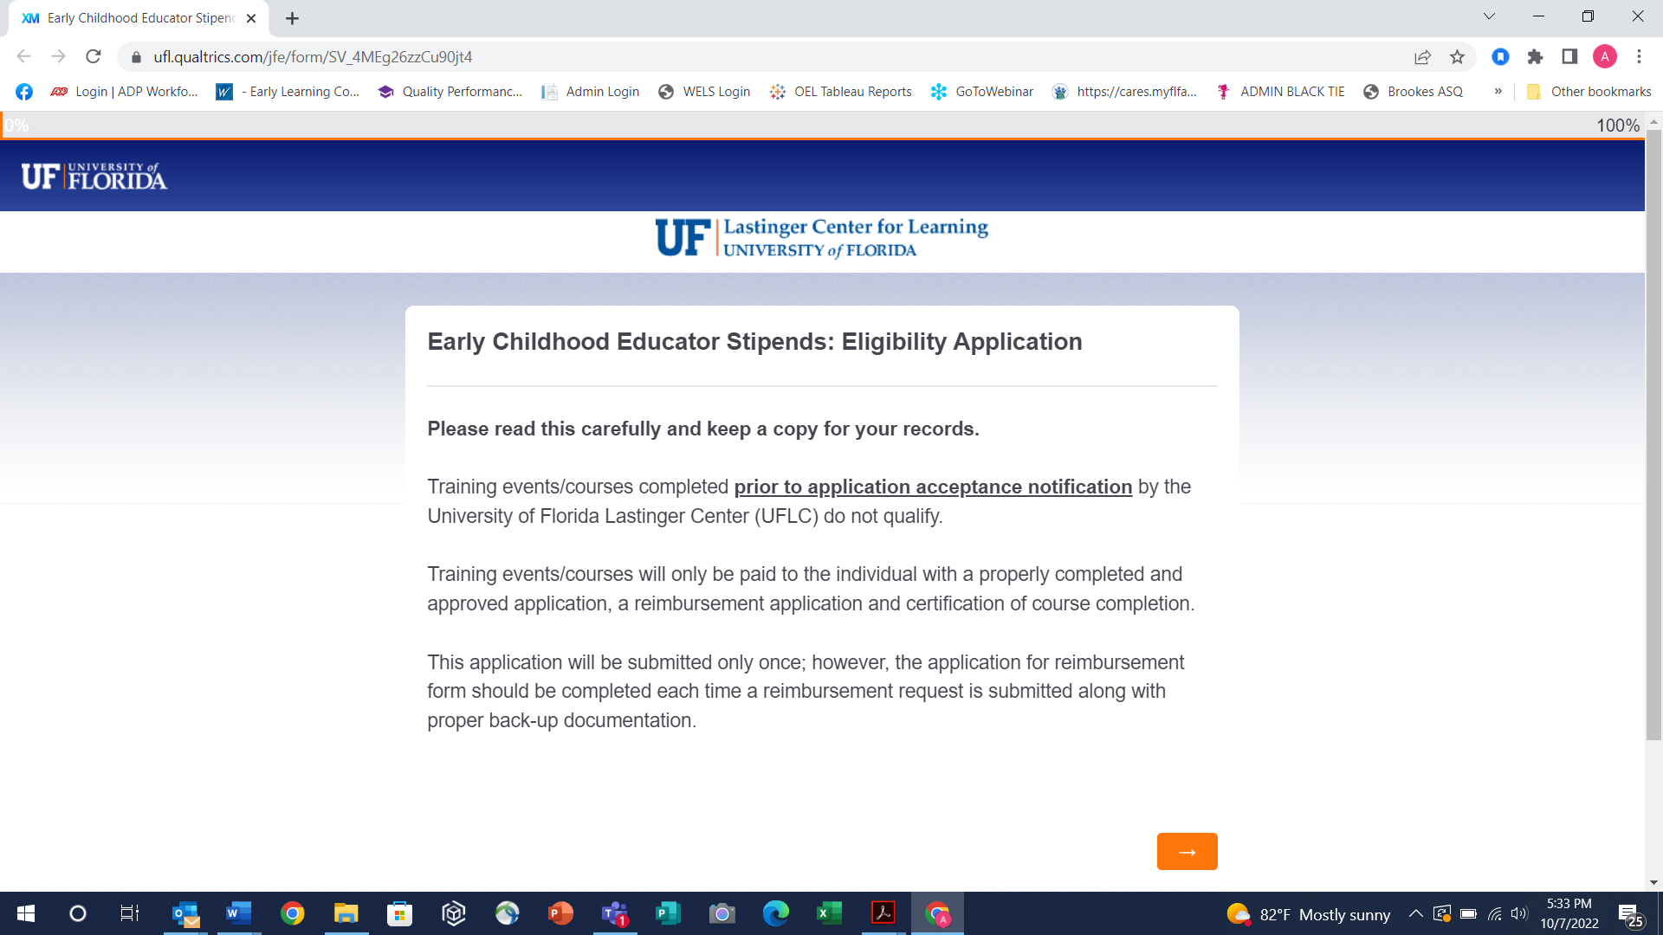
Step 1
Step 2: Complete the information below: First Name, Last Name, Email Address, Telephone Number, and Mailing Address.
Then choose which county and coalition you are from. You can only apply to the ELC where your center/home is physically located (your “home ELC”) for a training stipend.
Then Click the Orange Button to proceed.

Next Step
Step 3: Choose which category of educator applies to you. Click the orange button to proceed.
Next Step
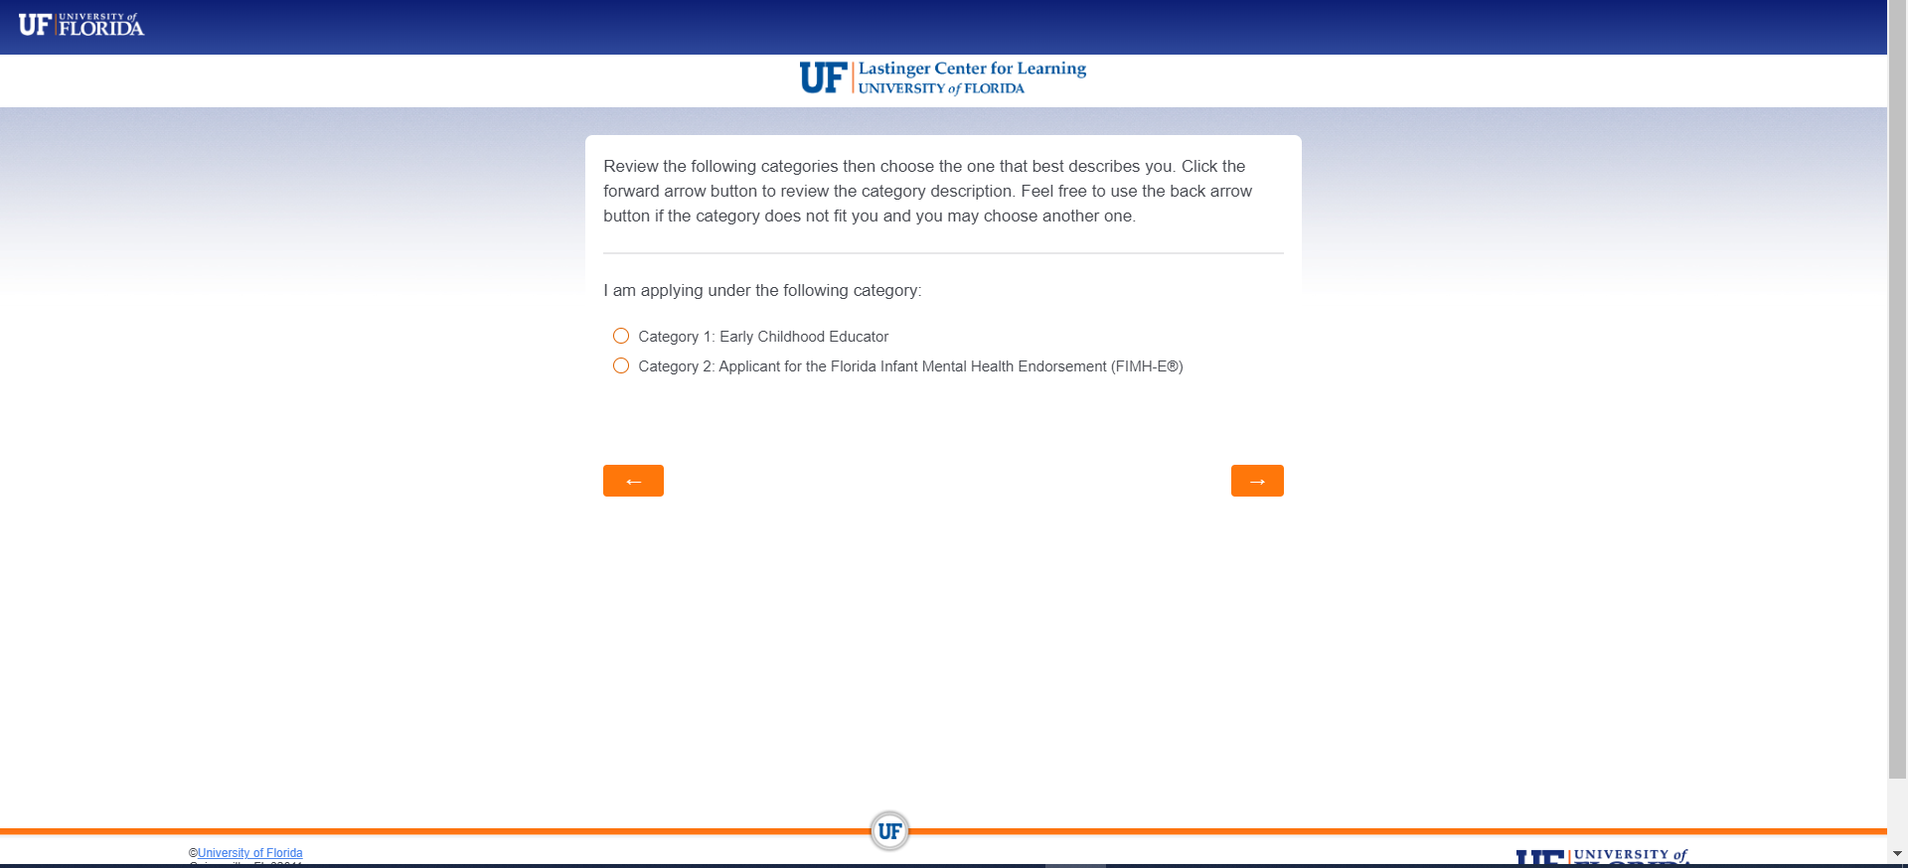

Step 4: Read the below message and click the orange to proceed
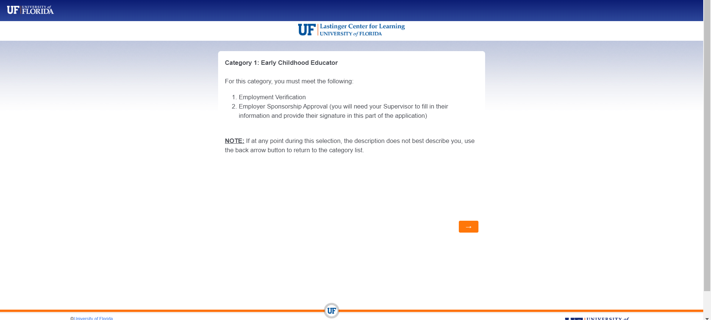
Next Step
Step 5: Click whether your school has either or both School Readiness and VPK contracts. Click the orange button to proceed.
Next Step
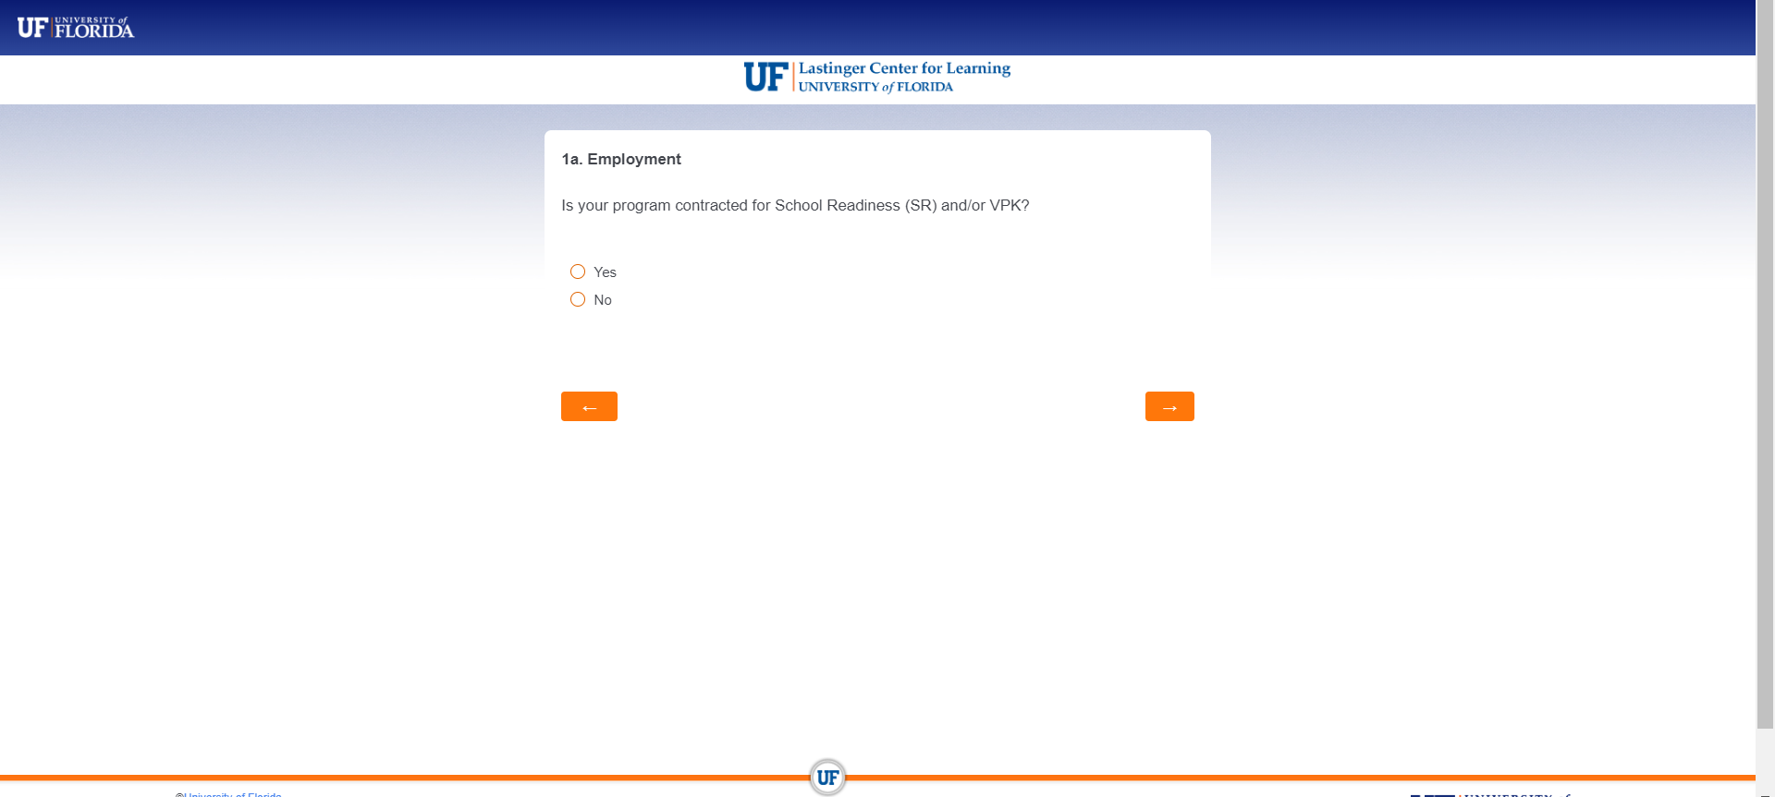

Step 6: Complete the next sections with support from your director/owner. Click the orange button to proceed.
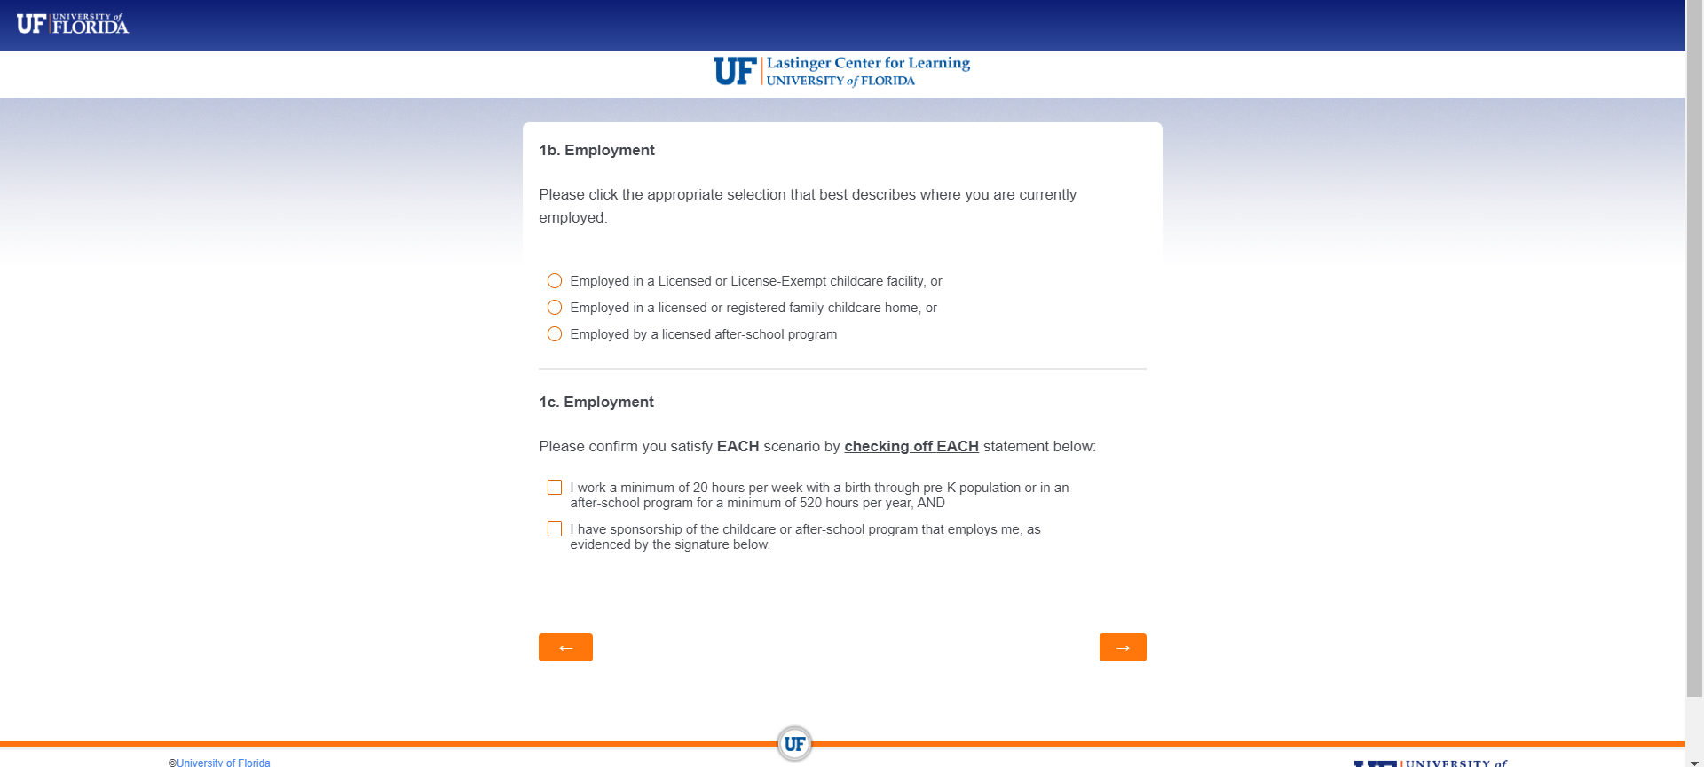
Next Step
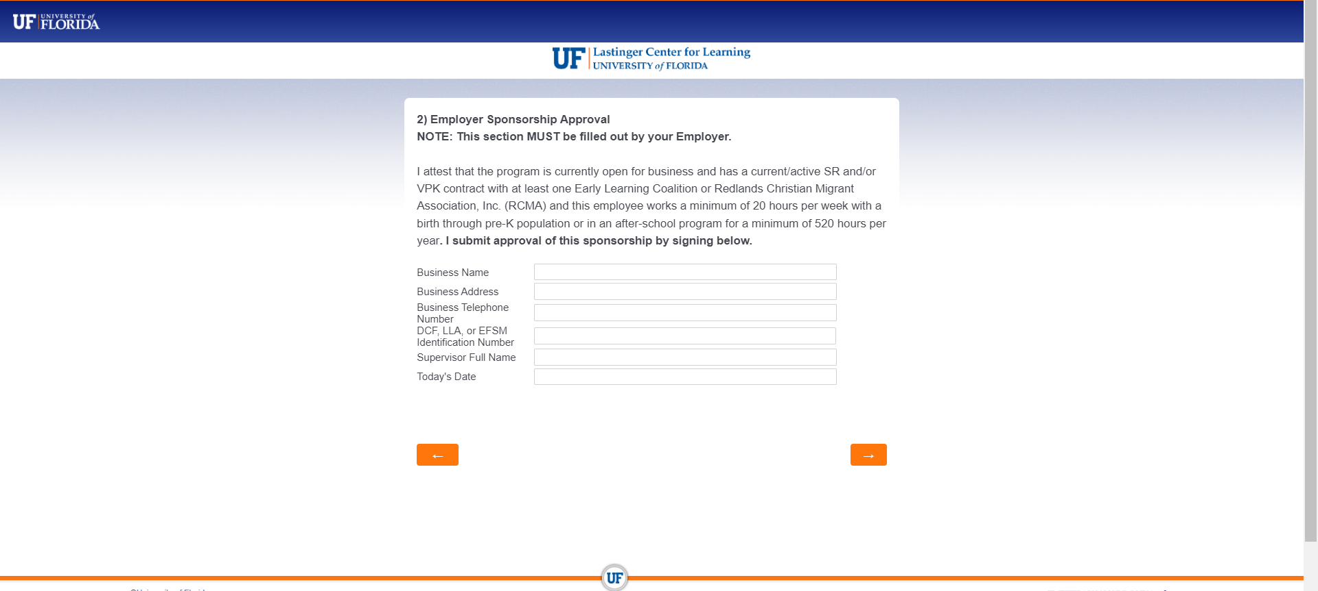
Next Step

Step 7: Sign and Click the orange button to proceed
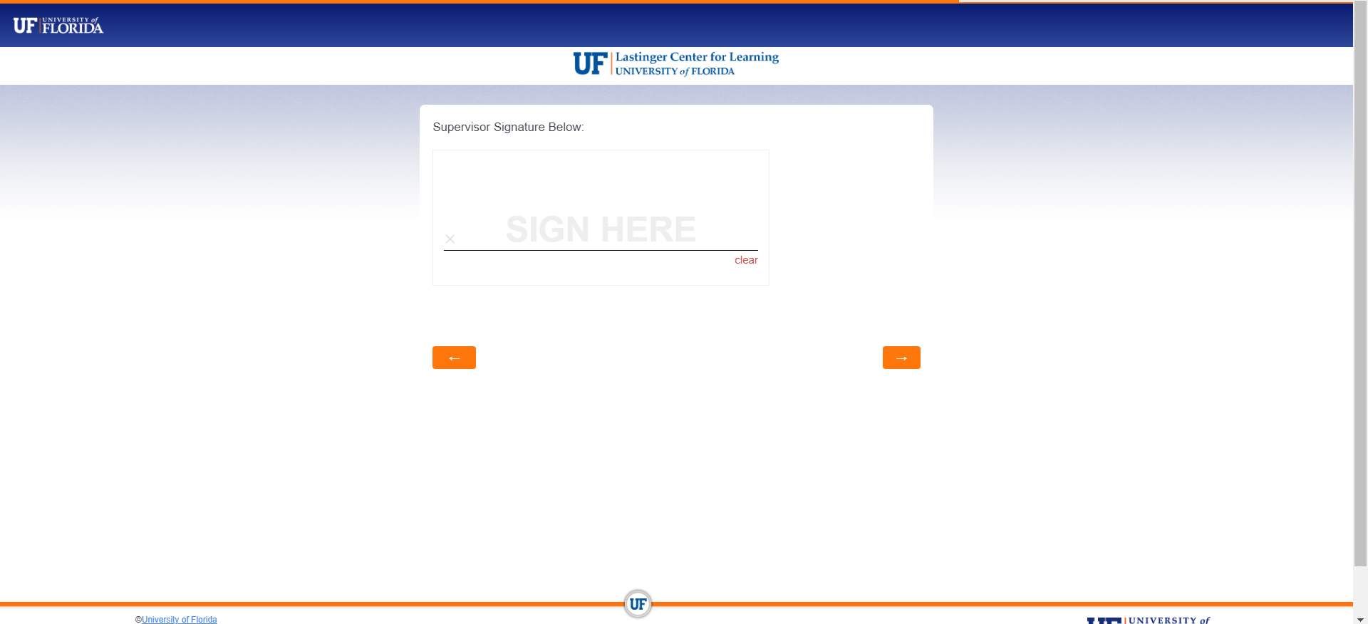
Next Step

Continue to the next page.
Step 8: Choose up to 3 courses that you want to participate in. Click the orange button to proceed.
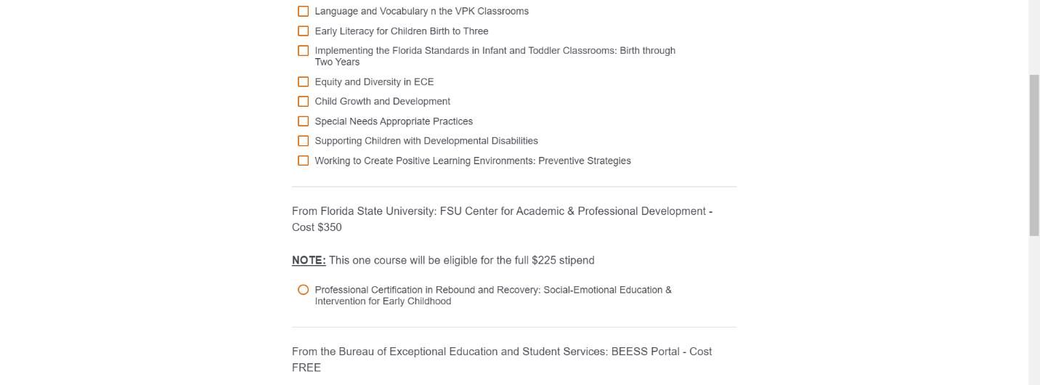
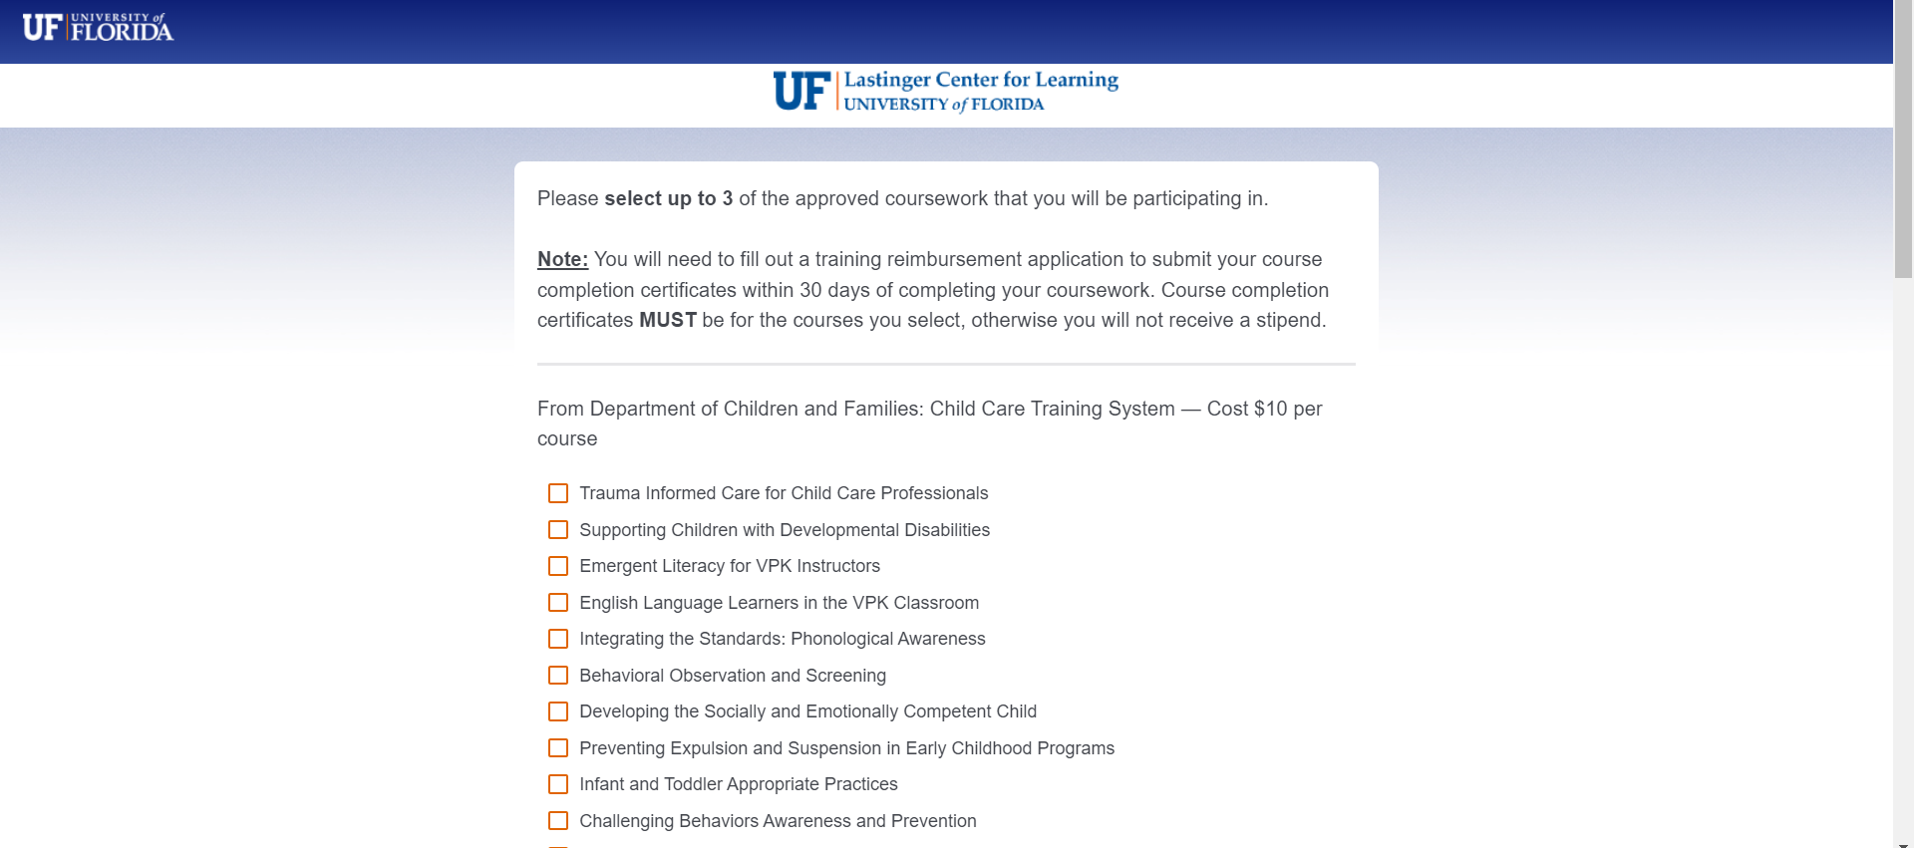

Who qualifies for a Statewide Sponsored Training Stipend?
  - For a center that only contracts with the State to provide VPK, only VPK staff are eligible.
  - For a center that only contracts with the state for School Readiness, School Readiness staff are eligible.
  - For a center that contracts for both VPK and School Readiness, both sets of staff

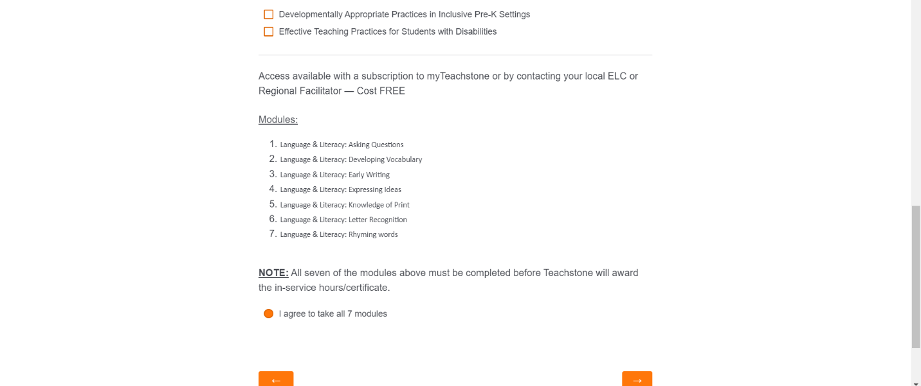

Next Step

Step 9: Certify that all your information is correct and complete. Click the orange button to proceed.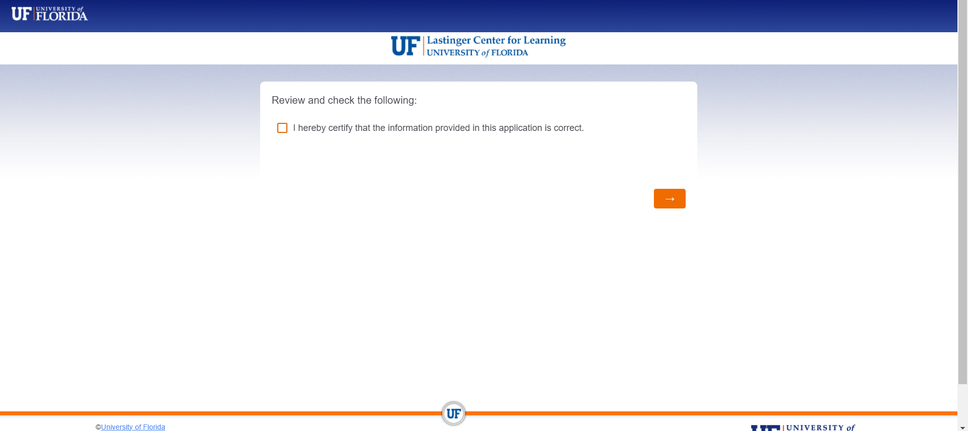
Next Step
Step 10: Once your application is complete, you will see the message below.
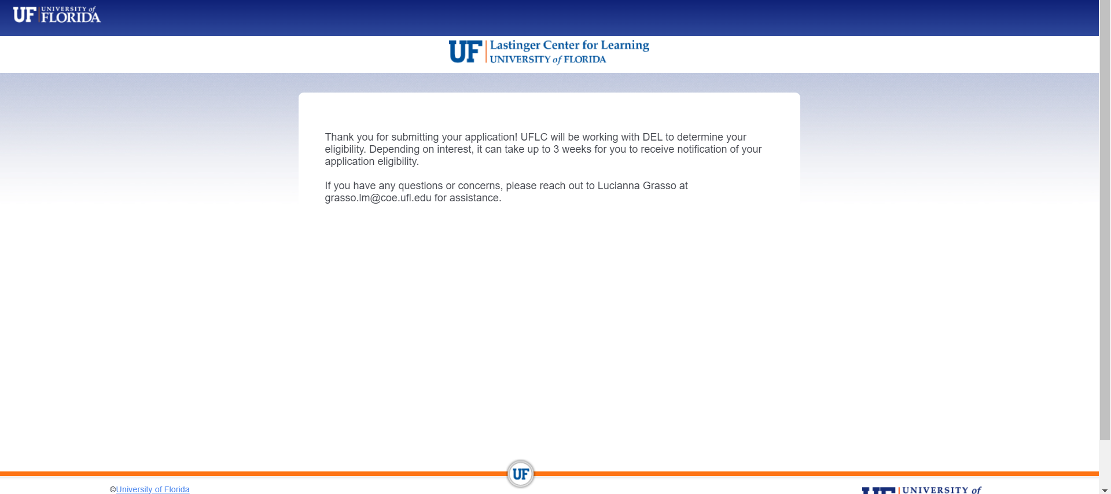
Q5) Which trainings are included in the statewide sponsored trainings?
There are four categories of trainings are all accessible online. Click here for the flyer

- Department of Children and Families (DCF): Child Care Training System — Cost $10 per course
- Florida State University: FSU Center for Academic & Professional Development
- Bureau of Exceptional Education and Student Services: BEESS Portal
- myTeachstone courses https://dashboard.teachstone.com/

Q6) Are the courses free?
The Department of Children (DCF) courses are NOT free. They are $10 each and can be found at the same website where you take the DCF 45hour training at https://training01-dcf.myflorida.com/studentsite/admin/login.jsf
The Florida State University training is NOT free. The cost is $350. You must pay that amount and once complete you are eligible for the full $225 stipend.

The Bureau of Exceptional Education and Student Services course are free.

The myTeachstone courses are free but registration for this site is necessary. If you do not have access to the myTeachstone website, please email Gordia Ross at gross@elcbroward.org Subscriptions for myteachstone are first come, first serve.

Q7) Will I receive in-service or CEU’s for the courses in addition to the stipend?
Each specific courses have different additional credits.

Q8) How do I choose which courses to take?
You are free to choose whichever courses you think would benefit or expand your skillset.
There are 18 DCF courses, you can take up to 3 courses for a stipend.
The Florida State University course is fully online and is self-paced. It includes 20 hours of course content and ten chapters of research-based readings, case scenarios, multi-media materials, assignments, and quizzes.
The Bureau of Exceptional Education and Student Services course are 10 hours each.
The myteachstone course includes seven modules and all must be completed to receive the in-service hours/certificate.

Q9) Are there any trainings available in Spanish?
The myTeachstone training has a Spanish option.

Q10) Do any of the DCF courses count towards the Voluntary Pre-K (VPK) Emergent Literacy 15-hour requirement?
Yes, the below courses count towards the VPK Emergent Literacy requirement.
  - Emergent Literacy for VPK Instructors (5 hrs./.5 CEUs)
  - Language and Vocabulary in the VPK Classrooms (5 hrs./.5 CEUs)
  - Building a Strong Foundation for Emergent Literacy (5 hours; 0.5 CEUs)

Q11) How much in mini-grant monies can a qualifying educator receive?
The maximum is $225 per educator.

Q12) Does my director or owner need to sign off on these trainings?
Yes, to receive the stipend your director/owner will need to assist you to complete the application form.

Q13) What if I am not working at the moment?
You would still need your most recent owner/director to sign the certification part of the form that would accompany your submission. All applicants have to have a sponsoring school.

Q14) My center is in Broward, but I also serve children in Miami-Dade families. Can I get stipends from both counties’ Coalitions?
You can only apply to the ELC where your center/home is physically located (your “home ELC”) for a training stipend.

Q15) What do I need to submit to get my stipend?
First, you will need to complete a reimbursement application through the University of Florida Lastinger Center (UFLC). Click to complete reimbursement application

Then, the Early Learning Coalition of Broward will reach out to you to complete additional paperwork such as your Stipend Vendor Update Form and W9.

The Early Learning Coalition of Broward County cannot process any stipends until the University of Florida Lastinger Center (UFLC) provides us with the list of educators of successful course completion.

The Early Learning Coalition of Broward County may need to request additional copies of your course completion certificates.
Q15) What does course completion mean?
It is proof that the course was completed. A certificate is issued when all items are complete.
For the DCF trainings, submit a copy of your CHILD CARE TRAINING TRANSCRIPT.
For myTeachstone, if you completed all 7 modules on language and literacy, please email all 7 course completion certificates to Lucianna Grasso at grasso.lm@coe.ufl.edu or upload 1 PDF file of all 7 certificates below.

Q16) Can my director/owner pay me?
No, each educator is paid individually by the ELC.

Q17) Can I receive a paper check?
Yes, all payment through the Early Learning Coalition of Broward County is through a paper check mailed to your home address.
Q18) Can I be paid by ACH, Zelle or Venmo?
No, due to the large volume of recipients all stipends will be received in the form of a check.

Q19) Can I apply each time I complete a course?
You must apply first to UFLC before completing your courses.
Q20) What if I have questions?
Please submit all questions to elcbpays@elcbroward.org

If there are any issues with your paperwork, such as incomplete or missing information, an ELC staff member will contact you.

Q21) How long does it take to receive my money?
Given the overwhelming response, please allow at least 8 weeks for processing.

Q22) What if I took a course already?
You cannot take a course again if you already completed it. Remember all courses must be approved through the application.

Q23) When does the training start?
Since all the trainings are self-paced and all are online, you can start taking courses once you have received approval on your application.

Q24) What if I already took the course and want to take it again for the stipend?
No. You may not retake courses.

