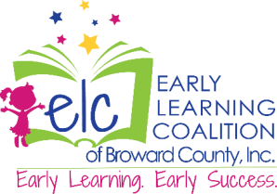

**ELC Family Services Points of Contact**

|  |  |  |  |
| --- | --- | --- | --- |
| **Manager** | **Programs** | **Phone contact** | **Email** |
| **Armara Rodriguez** | * Career Source Referrals * SR PLUS * VPK and VPK Re-enrollments (VPK Transfers) * Inbound and Outbound County Transfers * Provider Match (SRMT) | 954-377-2188 | [arodriguez@elcbroward.org](https://elcbrw-my.sharepoint.com/personal/amoore_elcbroward_org/Documents/Desktop/arodriguez@elcbroward.org) |
| **Christiana Belvant** | * Income Eligible/Redeterminations * Vulnerable Population (CSC funded childcare) * SR Provider Transfers | 954-377-2188 | [CBelvant@elcbroward.org](mailto:CBelvant@elcbroward.org) |
| **Gracy Haladjian** | * Income Eligible Waitlist Applications * Income Eligible Initial Enrollments | 954-377-2188 | [ghaladijan@elcbroward.org](https://elcbrw-my.sharepoint.com/personal/amoore_elcbroward_org/Documents/Desktop/ghaladijan@elcbroward.org) |
| **Kathleen Isaac** | * Income Eligible/Redeterminations * COSPN (County Special Needs) | 954-377-2188 | [KIsaac@elcbroward.org](https://elcbrw-my.sharepoint.com/personal/amoore_elcbroward_org/Documents/Desktop/KIsaac@elcbroward.org) |
| **Yanique Lyons** | * At Risk Childcare Referrals (Child Net and DCF) * Homeless Childcare Referrals * Diversion Childcare Referrals | 954-377-2188 | [ylyons@elcbroward.org](https://elcbrw-my.sharepoint.com/personal/amoore_elcbroward_org/Documents/Desktop/ylyons@elcbroward.org) |