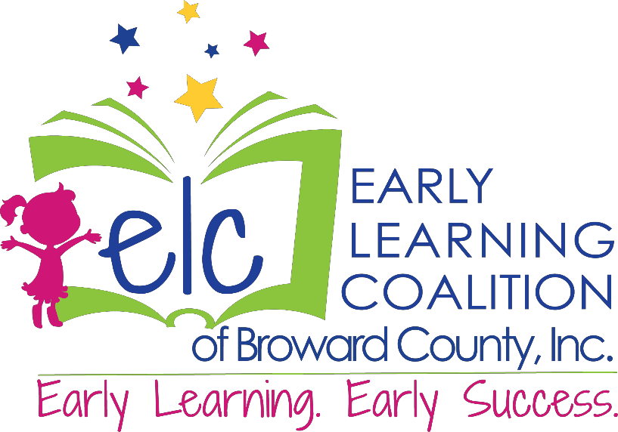

Early Learning Coalition Board of Directors Application

SUBMIT APPLICATION & RESUME TO:
Elsy Silvestre, Executive Assistant esilvestre@elcbroward.org
1475 W. Cypress Creek Road,
Suite 301
Fort Lauderdale, FL 33309
954-377-2183 FAX 954-377-2192

Applicant’s Name: Click or tap here to enter text.
(Last, First – include commonly used name)

Email Address: Click or tap here to enter text.

Cell Phone: Click or tap here to enter text.

Address: Click or tap here to enter text.

Current Employer: Click or tap here to enter text.

Current Occupation: Click or tap here to enter text.

Business Address: Click or tap here to enter text.

Specify preferred mailing address: Click or tap here to enter text.

EDUCATION

List postsecondary educational institutions (or highest) attended or professional certifications:

NAME & LOCATION DEGREE/CERTIFICATE RECEIVED DATES ATTENDED

COMMUNITY INVOLVEMENT

Please list community, civic, professional, business & other organizations of which you’re involved in (including professional/civic fraternal organizations):

ORGANIZATION POSITION(S) HELD DATES INVOLVED

Have you ever been elected/appointed to any public office in the state? If yes, please provide details:

POSITION/OFFICE TITLE DATES SERVED LEVEL OF GOV’T

Have you received any awards/recognition? If yes, list:
Click or tap here to enter text.

Do you have any other skills/recognition you would like to share with us?

Click or tap here to enter text.

PERSONAL STATEMENT
Please answer all questions: Why do you want to serve on the ELC’s Board? What do you hope to achieve as a board member? What is your vision for early childcare in Broward County?

Click or tap here to enter text.

PERSONAL HISTORY

Please check all that apply:
☐Have you ever been removed from a board(s), committee(s), council(s), etc.?
☐Has probable cause ever been found that you were in violation of Part III, Chapter 112, F.S., Code of Ethics for Public Officers & Employees?
☐Are you now, or have you in the last 3 years, been a member of any club/organization that in practice restricts (restricted) membership on the basis of race, religion, national origin, or gender?
☐Have you ever been convicted/withheld adjudication for violation of any federal, state or municipal law/regulation/ordinance?
☐Have you, your immediate family (spouse, child, parent(s), sibling(s) or businesses of which your immediate family have been owners, officers, or employees, held any contractual/direct dealings with any state/local governmental agency in Florida during the last four years (including the office/agency to which you’ve been appointed or are seeking appointment)?
If you said yes to any of the above questions, please explain:
Click or tap here to enter text.

REFERENCES
List 3 professional references who have known you well within the past 5 years (exclude relatives):
NAME PHONE NUMBER

Click or tap here to enter text. | Click or tap here to enter text.
Click or tap here to enter text. | Click or tap here to enter text.
Click or tap here to enter text. | Click or tap here to enter text.

If required by law or administrative rule, will you file financial disclosure statement(s):
☐Yes ☐ No

QUESTIONS FOR CHILDCARE PROVIDERS ONLY

Are you employed by a private childcare provider/employee who receives funding services from the ELC of Broward County? ☐Yes ☐No
If yes, are you: ☐For Profit ☐Not for Profit ☐Faith Based ☐Other: Click or tap here to enter text.

**Please Note that the designated child care provider representative (non-faith based) serving on Early Learning Coalition’s Board must be from a for-profit child care provider.

Approximately what percentage of the children/families attending your child care center/home receive child care subsidies? Click or tap here to enter text.

Approximately what percentage of the children/families attending your child care center/home receive VPK? Click or tap here to enter text.

Is your center/home accredited by a recognized agency? If yes, provide details/expiration: Click or tap here to enter text.

Have you ever been determined to be a LLP (Low Performing Provider) by the FDOE (FL Dept. of Education)? ☐Yes ☐No

A provider may not be eligible for board membership, if during the last 24 months it:

☐ Failed to repay an overpayment by the required date after the ELC or their sub-recipient discovered the overpayment and requested repayment
☐ Submitted a monthly attendance roster resulting in an overpayment that exceeded 20% of the payment for a calendar month due to the provider’s inaccurate reporting of a student’s attendance
☐ Submitted a monthly attendance roster containing fraudulent reporting or other intentional misreporting of a student’s attendance
☐ Failed to comply with the terms of the ELC’s School Readiness Provider Agreement
☐ Provider’s license status, as recorded in CCIS, is “Revocation Action Pending,” “Suspension Action Pending/Suspended,” or “Closed” ‘

☐ Provider’s accreditation status has expired or been rescinded (for providers not licensed by Broward Co. Child Care Licensing) – s.1002.55(3)b., F.S.
☐ Identified on the FSDA or Florida Disqualification List
☐Received more than Class 1 or Class 2 Violations from Broward County Child Care Licensing and Enforcement

COMMITMENT AND OPERATIONAL STATEMENTS

TIME COMMITMENT: Serving as an ELC Board Member will require a commitment of time, including attendance at regular Board meetings and committee involvement, visiting community program sites, ELC events, and becoming educated about many aspects of early childhood development and school readiness. Board meetings are generally held once every other month.

CONFLICT OF INTEREST: A conflict of interest may occur when an item is presented for a vote that will directly affect you, your employer, your immediate family or another organization with which you are affiliated. Conflict of interest rules generally require you to disclose the conflict and abstain from discussion/vote on the matter.

MEMBERSHIP REQUIREMENTS: School Readiness legislation & the Office of Early Learning Policies (OEL-PG-0002-10 “Early Learning Coalition Board Membership”) govern the requirements for Board membership. Please see applicable policies.

SUNSHINE LAW: The ELC of Broward County is a legislatively mandated group and operates under the general Florida guidelines of The “Sunshine” Law.

Private Provider, Faith Based Provider & Special Needs Representative: Serving in such capacity requires a commitment to communicate Board business to constituents.

I understand the requirements of Board Membership for the Early Learning Coalition of Broward County, Inc. I agree that I have carefully and personally prepared/read the answers to the foregoing questions. The information in this application is complete and true.

Click or tap here to enter text.
NAME

Click or tap here to enter text.
Signature

Click or tap to enter a date.
Date

PRIVATE-SECTOR MEMBER

I,Click or tap here to enter text. , have read and reviewed OEL-PG-0002-10 “Early
PRINT NAME
Learning Coalition Board Membership” and that I meet the eligibility requirements for Early Learning Coalition Private-Sector membership in Broward County, as reflected therein, and that I do not have a substantial financial interest in early learning programs as defined by said policies. I agree to immediately notify the Board of Early Learning Coalition of Broward County, Inc. in writing, should that change during my term.

Click or tap here to enter text.
SIGNATURE

Click or tap to enter a date.
DATE

Self-Identification

Completion of the following section is optional:

Race:

☐White, non-Hispanic | ☐Native Hawaiian/Other Pacific Islander American
☐Hispanic | ☐Indian/Alaska Native
☐Black/African American
☐Asian

Gender:

☐Female ☐Male

